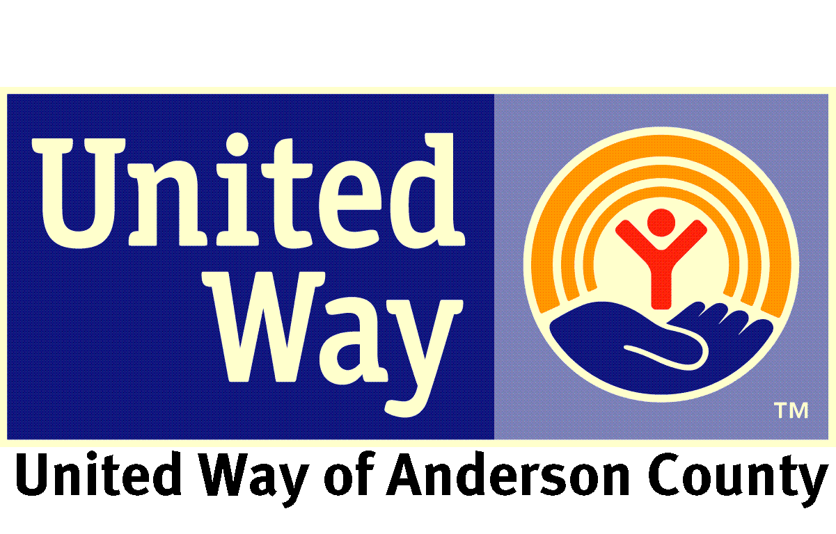
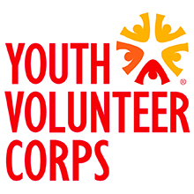
YVC Team Leader Position Description

Program: Youth Volunteer Corps of Anderson County, a program of United Way of Anderson County, is one of more than 40 YVC programs throughout the U.S. and Canada dedicated to addressing community needs and inspiring youth for a lifetime commitment to service.
Title: YVC Team Leader
Position Summary: The primary role of a YVC Team Leader is to plan frequent, diverse, high-quality service-learning projects and to recruit, train and supervise diverse teams of 11-18 year-old youth to serve as volunteers on those projects.
Position Impact: YVC Team Leaders play a critical role in advancing the mission of the Youth Volunteer Corps, which include engaging disadvantaged youth in team-based service-learning projects to develop needed employment skills. The service opportunities Team Leaders create can have a transformative impact on youth’s lives while also addressing urgent needs in their community.
Position Responsibilities:
- Collaborate with staff, youth, schools, agencies and other partners to develop frequent, diverse, high-quality service-learning projects that address important community needs while providing an educational and rewarding experience for youth.
- Recruit diverse teams of youth, including disadvantaged youth, to complete YVC projects.
- Supervise YVC projects by working alongside Youth Volunteers and the YVC Program Director, acting as liaison between agency and youth, and ensuring a safe, educational, fun and rewarding service experience.
- Integrate educational and leadership components into projects through the use of icebreakers, team builders, service-learning and reflection activities that promote teamwork and social interaction while increasing understanding and appreciation for the causes being served.
- Create leadership opportunities for youth to develop new job and life skills, from helping to plan projects and special events to recruiting new youth and guiding overall program direction.
- Maintain regular communication with local youth, schools, agencies and colleagues throughout the YVC network to advertise current projects, plan new opportunities, and share achievements.
- Attend all mandatory United Way and YVC-planned training and events.
- Act as a role model for Youth Volunteers and an advocate for youth service in general.
Applicants must:
- Be at least 18 years old on their first day of service.
- Be a U.S. citizen or lawful permanent resident alien.
- Have a high school diploma or G.E.D or agree to obtain one during their term of service.
- Submit to a full background check, including a sex offender registry check and state criminal history registry check. This position has recurring access to vulnerable populations and selection is contingent upon satisfactory results of these checks.

Preferred Qualifications:
- Excellent oral and written communication skills
- Independent, self-motivated work style
- Excellent follow-through and strong organization skills
- Basic computer skills
- Available during the week when most YVC Summer of Service projects occur, as well as occasional Saturdays
- Outgoing, friendly and able to multitask
- Experience working with middle and high school age youth, especially disadvantaged youth
- Volunteer experience
- Knowledge of service-learning
- Access to a reliable vehicle and valid driver’s license
- Willingness to get your hands dirty
- Passion for helping youth succeed
Benefits:
- A wealth of professional experience, including training and leading teams of youth; researching, designing and leading multi-dimensional service-learning projects; learning project-specific skills from construction to mentoring children; and working alongside a variety of people and agencies who can be future contacts along your career path.
- Mileage reimbursement
Days/Hours of Service: Orientation and training days, participation in Summer of Service Mondays-Fridays 8:00-3:00 for 4-6 weeks in June and July, and participation and planning for any other YVC service projects throughout the summer. Days/hours are flexible and depend on what is agreed upon by YVC Team Leader and YVC Program Director.
Supervisor: Ellie Phillips, YVC Program Director
Service Location: United Way of Anderson County
Contact: 864-226-3438 ext. 114, ellie.phillips@uwandersoncty.com

